2.Practice Questions

18 January 2024

20:26

1.Ask the user for a string and print out whether this string is a palindrome or not.

import 'dart:io';

void main() {

  // Take user input

  stdout.write('Enter a string: ');

  String userInput = stdin.readLineSync()!;

  // Remove non-alphanumeric characters and convert to lowercase

  String cleanedInput = userInput.replaceAll(RegExp(r'[^a-zA-Z0-9]'), '').toLowerCase();

  // Compare the original and reversed strings

  if (cleanedInput == cleanedInput.split('').reversed.join('')) {

    print('$userInput is a palindrome!');

  } else {

    print('$userInput is not a palindrome.');

  }

}

Output:

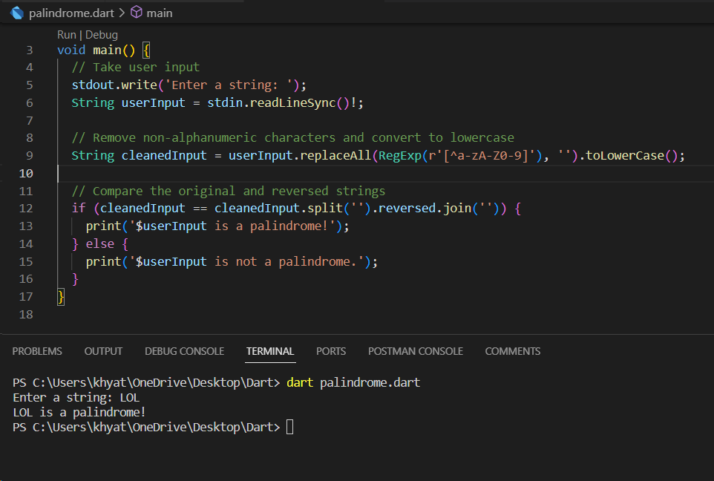

2. Generate a random number between 1 and 100. Ask the user to guess the number, then tell them whether they guessed too low, too high, or exactly right.

import 'dart:io';

import 'dart:math';

void main() {

  // Generate a random number between 1 and 100

  Random random = Random();

  int randomNumber = random.nextInt(100) + 1;

  int userGuess;

  int attempts = 0;

  print('Welcome to the Number Guessing Game!');

  do {

    // Take user input

    stdout.write('Enter your guess (between 1 and 100): ');

    String? input = stdin.readLineSync();

    // Validate user input

    if (input != null) {

      userGuess = int.tryParse(input) ?? 0;

    } else {

      userGuess = 0;

    }

    // Check user's guess

    if (userGuess > 0 && userGuess <= 100) {

      attempts++;

      if (userGuess < randomNumber) {

        print('Too low! Try again.');

      } else if (userGuess > randomNumber) {

        print('Too high! Try again.');

      } else {

        print('Congratulations! You guessed the number $randomNumber in $attempts attempts.');

      }

    } else {

      print('Please enter a valid number between 1 and 100.');

    }

  } while (userGuess != randomNumber);

}

Output:

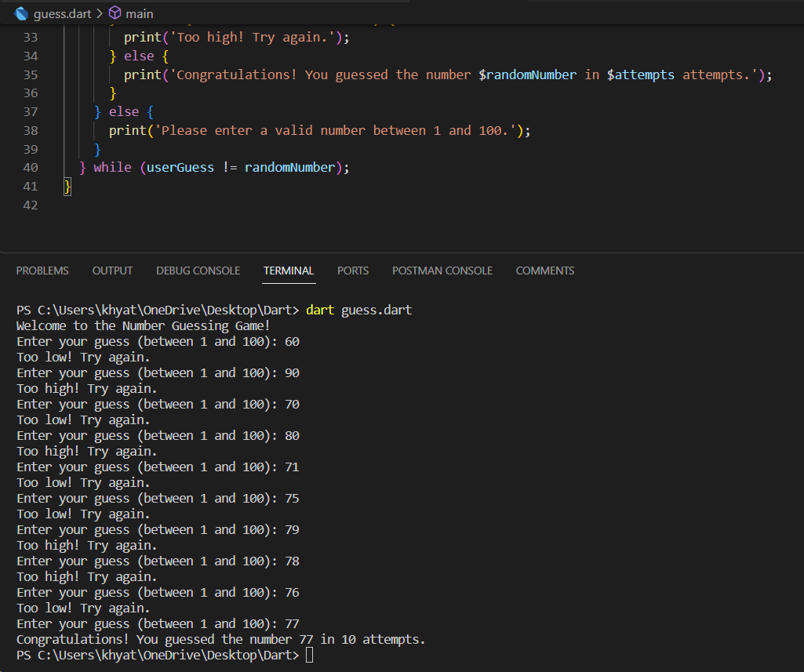

3. Write a program that asks the user how many Fibonacci numbers to generate and then generates them.

import 'dart:io';

void main() {

  print('Enter the number of Fibonacci numbers to generate: ');

  // Take user input

  String? input = stdin.readLineSync();

  int count = int.tryParse(input!) ?? 0;

  // Generate and print Fibonacci numbers

  int first = 0, second = 1;

  print('Fibonacci Sequence:');

  for (int i = 0; i < count; i++) {

    stdout.write('$first ');

    int next = first + second;

    first = second;

    second = next;

  }

}

Output:

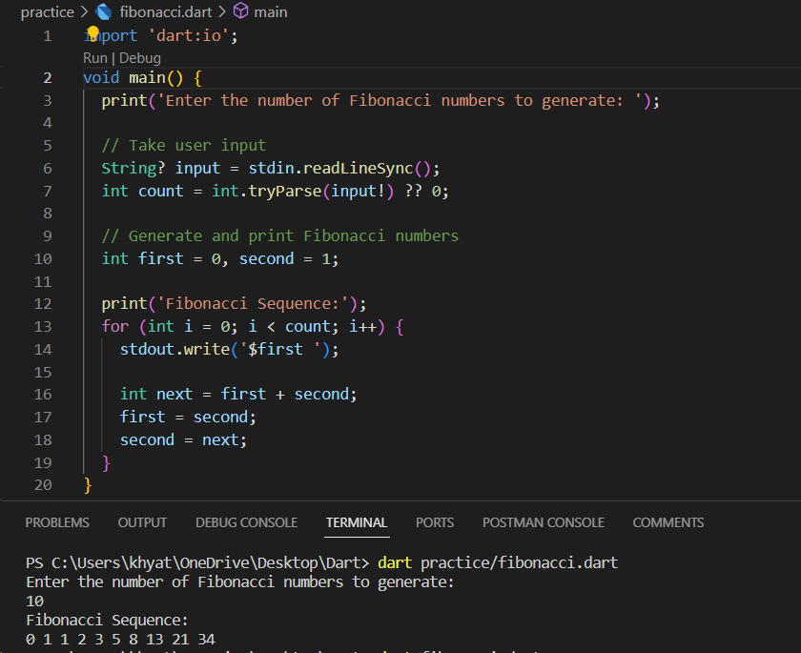

4. Write a program that takes a list and returns a new list that contains all the elements of the first list minus all the duplicates.

void main() {

  List<int> originalList = [1, 2, 2, 3, 4, 4, 5, 6, 6, 7, 8, 8, 9];

  List<int> uniqueList = removeDuplicates(originalList);

  print('Original List: $originalList');

  print('List without Duplicates: $uniqueList');

}

List<int> removeDuplicates(List<int> inputList) {

  List<int> result = [];

  for (int element in inputList) {

    if (!result.contains(element)) {

      result.add(element);

    }

  }

  return result;

}

Output:

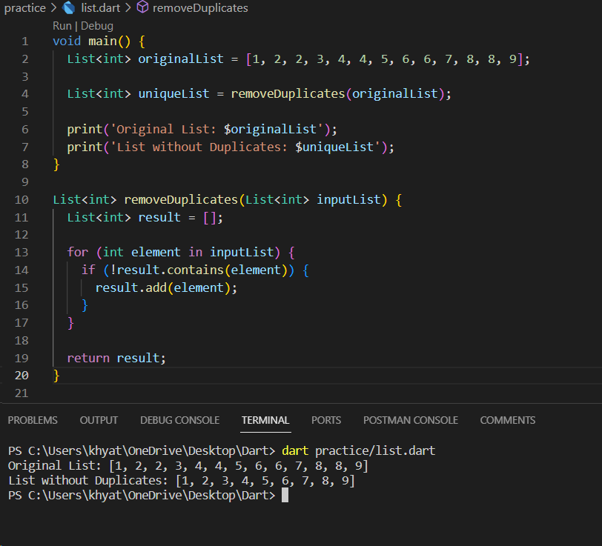

5. Write a program that asks the user for a long string containing multiple words. Print back to the user the same string, except with the words in backwards order.

import 'dart:io';

void main() {

  // Take user input

  stdout.write('Enter a long string with multiple words: ');

  String? input = stdin.readLineSync();

  // Check if input is not null and not empty

  if (input != null && input.isNotEmpty) {

    // Split the string into a list of words

    List<String> words = input.split(' ');

    // Reverse the order of the words

    List<String> reversedWords = words.reversed.toList();

    // Join the reversed words to form the final string

    String reversedString = reversedWords.join(' ');

    // Print the result

    print('Original String: $input');

    print('String with Words in Reverse Order: $reversedString');

  } else {

    print('Invalid input. Please enter a non-empty string.');

  }

}

Output:

